Name:

ID:

Submit here: <https://docs.google.com/forms/d/e/1FAIpQLSfHeiVxsmobcVqbNbxM5AHZIngIGqR-6Ah8sWROvVZg4pOiTw/viewform>

PART 1:

1. Consider the following:

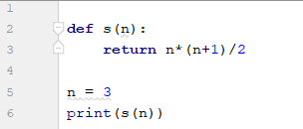

* What is **s(15)**?

|  |  |
| --- | --- |
| 15 | 105 |
| 120 | 6 |
| 3 | 100 |

1. Consider the following:

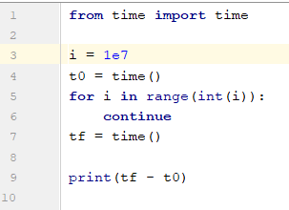

* What happens to tf-t0 as i gets larger?

|  |  |
| --- | --- |
| Gets smaller | Gets larger |
| Nothing | Error |

* Which of the following best describes the code?

|  |  |
| --- | --- |
| Loop through 10 million integers | Use the continue keyword to create an infinite loop |
| Prints the difference between two complex numbers | Runs a large for loop and calculates the difference between two integers |
| Outputs the time required to run a for loop | Converts the complex number 1e7 to an integer |

1. Consider the following:

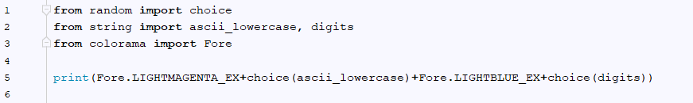

* Which of the following is a possible output?

|  |  |
| --- | --- |
| m50 | Y0 |
| A7 | l0 |
| A17 | A70 |
| a1 | z10 |

1. Consider the following:

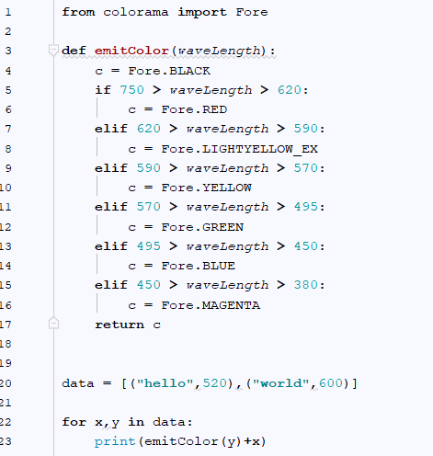

* Change data so that the output becomes (type answer below):



Part 2: [Lists](https://runestone.academy/runestone/books/published/thinkcspy/Lists/intro-Lists.html)

1. How are strings different than lists? (10.1)
2. What type of data are the elements in the following list: (10.2)



1. Evaluate the following: (10.3)

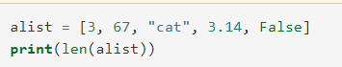

1. Evaluate the following: (10.4)



1. Evaluate the following: (10.5)

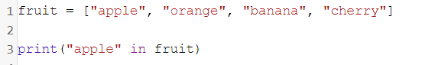

1. Evaluate the following: (10.5)

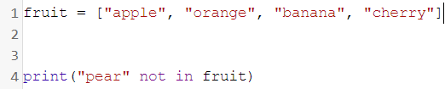

1. Evaluate the following: (10.6)

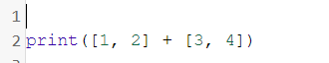

1. Evaluate the following: (10.6)



1. Consider the following: (10.7)

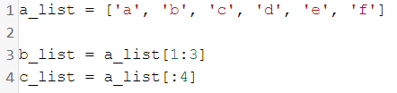

* What is len(b_list)

Part 3:

1. The Goldbach conjecture is a famous unsolved problem in mathematics stating that any even integer can be decomposed into the sum of two prime numbers: *n = p + q*, where n is any integer and p and q are both primes. Use Python to find Goldbach decompositions for the following integers:

|  |  |  |
| --- | --- | --- |
| n | p | q |
| 4 | 2 | 2 |
| 18 |  |  |
| 98 |  |  |
| 110 |  |  |
| 556 |  |  |

Paste code below:

You can use the following list of prime numbers in your code:

primes = [2, 3, 5, 7, 11, 13, 17, 19, 23, 29, 31, 37, 41, 43, 47, 53, 59, 61, 67, 71, 73, 79, 83, 89, 97, 101, 103, 107, 109, 113, 127, 131, 137, 139, 149, 151, 157, 163, 167, 173, 179, 181, 191, 193, 197, 199, 211, 223, 227, 229, 233, 239, 241, 251, 257, 263, 269, 271, 277, 281, 283, 293, 307, 311, 313, 317, 331, 337, 347, 349, 353, 359, 367, 373, 379, 383, 389, 397, 401, 409, 419, 421, 431, 433, 439, 443, 449, 457, 461, 463, 467, 479, 487, 491, 499, 503, 509, 521, 523, 541, 547, 557, 563, 569, 571, 577, 587, 593, 599, 601, 607, 613, 617, 619, 631, 641, 643, 647, 653, 659, 661, 673, 677, 683, 691, 701, 709, 719, 727, 733, 739, 743, 751, 757, 761, 769, 773, 787, 797, 809, 811, 821, 823, 827, 829, 839, 853, 857, 859, 863, 877, 881, 883, 887, 907, 911, 919, 929, 937, 941, 947, 953, 967, 971, 977, 983, 991, 997]